

**Department of CSE**

**CSE209 Lab**

**Course Name: Electrical Circuits**

**Course Code: CSE209**

**Section No: 2**

**Experiment No: 06**

**Name of the Experiment:** Verification of Thevenin’s Theorem.

**Date of submission: 11/09/21**

Student’s Name: Md Abdul Ahad Rifat

Student’s ID: 2020-1-60-215

**Submitted to**

Rashedul Amin Tuhin

Senior Lecturer

Department of Computer Science and Engineering

East West University

**Objectives:**

1. To verify the Thevenin’s theorem theoretically, experimentally, and using PSpice simulation.

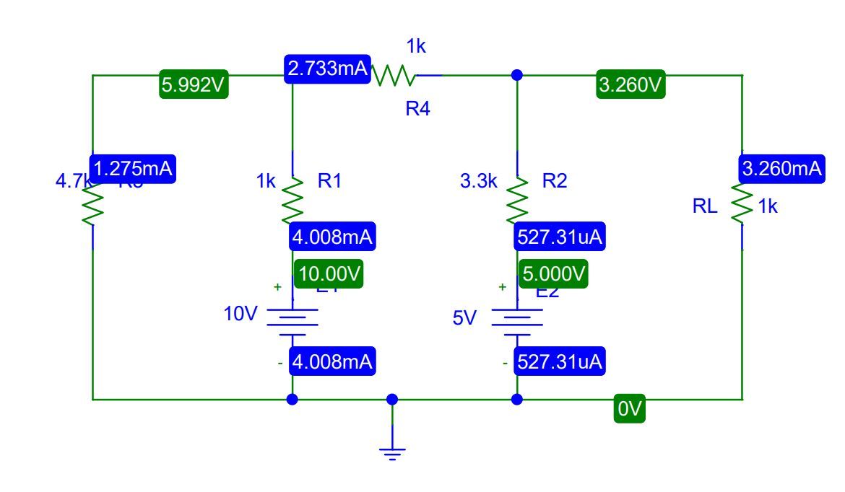**Circuit Diagram(s):**

**Figure 1.PSpice Schematic diagram for circuit 1**

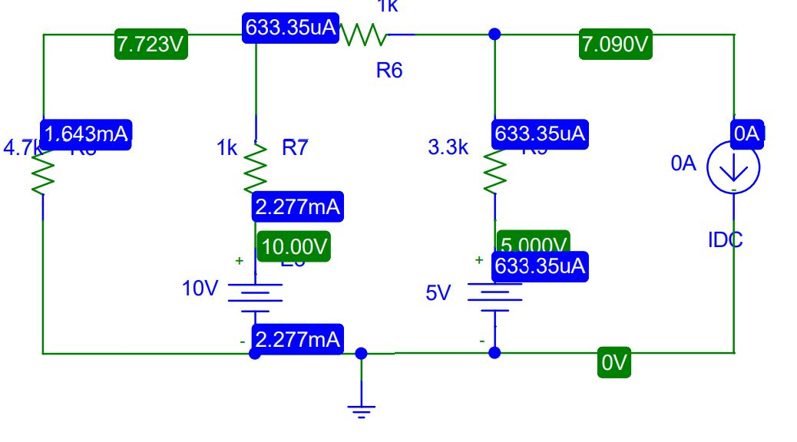

**Figure 2.PSpice Schematic diagram for circuit 2**

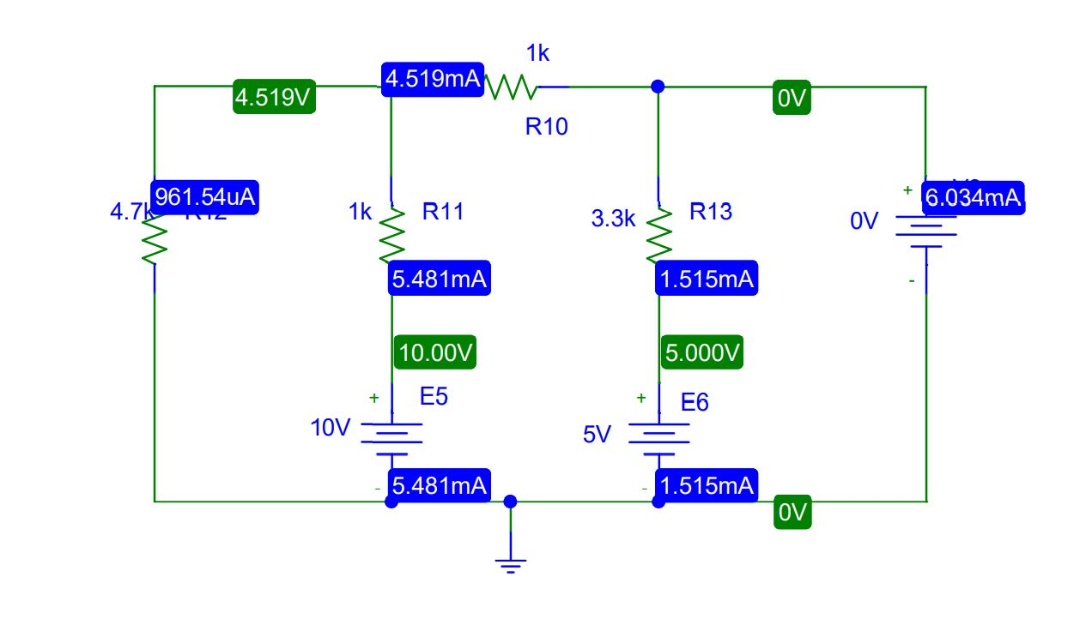

**Figure 3.PSpice Schematic diagram for circuit 3**

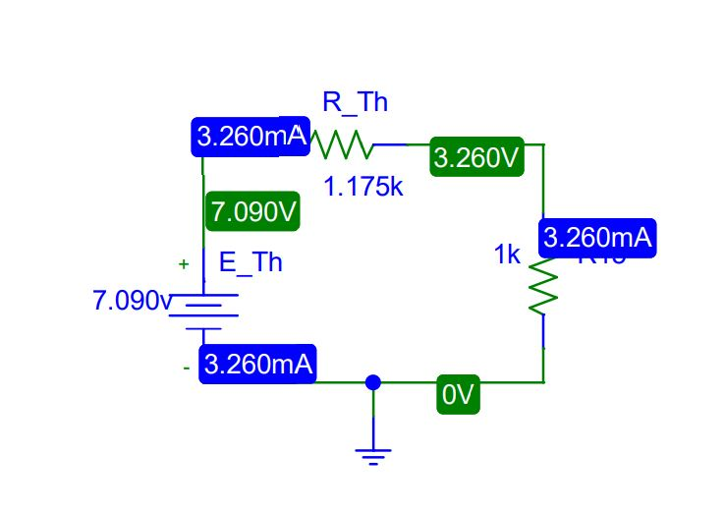

**Figure 4.PSpice Schematic diagram for circuit 4**

**Experimental Datasheet:**

**Table 1.Experimental Datasheet for determining Thevenin’s equivalent circuit.**

|  |  |  |  |  |  |  |
| --- | --- | --- | --- | --- | --- | --- |
| **Measured**  **Value of**  ***E1 (V)*** | **Measured**  **Value of**  ***E2 (V)*** | **Measured**  **Value of**  ***VL(V)*** | **Measured**  **value of**  ***IL* *(mA)*** | **Measured**  **value of**  ***VOC (V)*** | **Measured**  **value of**  ***ISC* *(mA)*** | **Measured**  **values of**  **resistors**  **Ω** |
| **10** | **5** | **3.26** | **3.26** | **7.090** | **6.034** | **R1 = 1K**  **R2 = 3.3K**  **R3 = 4.7K**  **R4 = 1K**  **RL = 1K** |

**Table 2.Experimental Datasheet for Thevenin’s equivalent circuit.**

|  |  |  |  |
| --- | --- | --- | --- |
| **Eth = *VOC*** | **Rth = *VOC / ISC*** | **Measured Value of *VL*** | **Measured Value of *IL*** |
| **7.090** | **1.175KΩ** | **3.26** | **3.26** |

**Post-Lab Report Questions and Answers:**

1. Theoretically calculate VL and IL in Figure 1 using measured values of *E1, E2, R1, R2*, *R3, R4*, and *RL*. Then theoretically calculate *VOC* in Figure 2 and *ISC* in Figure 3 using measured values of *E1, E2, R1, R2, R3, R4*, and *RL*. From the values of *VOC* and *ISC*, determine *ETh*  and *RTh.* Theoretically calculate *VL* and IL in Figure 4 using calculated values of *ETh* and *RTh* and the measured value of *RL*. Verify the Thevenin’s theorem from calculated data?

**Answer:**

**In figure 1** Applying KVL all the Mesh we get,

$$\left(5.7k\right)i_{1}-\left(1k\right)i_{2} = -10$$

$$\left(-1k\right)i_{1}+\left(5.3k\right)i_{2}-\left(3.3k\right)i_{3}= 10-5$$

$$\left(-3.3k\right)i_{2}+\left(4.3k\right)i_{3}= 5$$

So*, IL*= 3.26mA and *VL*= 3.26V

**In figure 2,** is in open circuit,

So we are applying KCL at node x,

*ETh = VOC =*

Applying KVL at mesh 1 and 2,

$$\left(5.7k\right)i_{1}-\left(1k\right)i_{2} = -10$$

$$\left(-1k\right)i_{1}+\left(5.3k\right)i_{2}-\left(3.3k\right)i_{3}= 10-5$$

$$i_{2}=0.633mA$$

*VOC =*

*=*7.090V

**In figure 3,** Applying KVL all the Mesh we get,

$$\left(5.7k\right)i_{1}-\left(1k\right)i_{2} = -10$$

$$\left(-1k\right)i_{1}+\left(5.3k\right)i_{2}-\left(3.3k\right)i_{3}= 10-5$$

$$\left(-3.3k\right)i_{2}+\left(3.3k\right)i_{3}= 5$$

$$So,I_{SC}=6.034mA$$

$$R_{Th}=\frac{V_{OC}}{I_{SC}}$$

$$= \frac{7.089}{6.034m}$$

$=$ 1.175kΩ

**In figure 4,**

$$I_{L} = \frac{7.089}{1.175K+1K}$$

= 3.26mA

*VL*= 3.26mA $×$ 1kΩ = 3.26V

1. Compare the measured values and the calculated values from step 1 and comment on any observed discrepancy.

**Answer:**

Since this is not actual lab this is a simulation, so there is no discrepancy between the measured values and the calculated value. But in reality there would be a discrepancy because that time temperature and depends circuit connection the value will be some change.

1. Using PSpice, simulate the circuit of Figure 1 and determine VL and IL. Simulate the circuit of Figure 2 and determine VOC. For this purpose, connect a 0A current source between nodes a and b. Simulate the circuit of Figure 3 and determine ISC. For this purpose, connect a 0Vvoltage source between nodes a and b. Determine the values of Eth and Rth. Simulate the circuit of Figure 4 and determine VL and IL. Verify the Thevenin’s theorem from simulated data.

**Answer:**

Using PSpice, simulate the circuit of Figure 1 and VL = 3.26V and IL =3.26mA. Simulate the circuit of Figure 2 and this time we get VOC = 7.090V. For this purpose, we connect a 0A current source between nodes a and b. Simulate the circuit of Figure 3 and get ISC =6.034mA. For this purpose, we connect a 0Vvoltage source between nodes a and b. The values of Eth =7.090V and Rth =1.175KΩ. Simulate the circuit of Figure 4 and get VL =3.26V and IL = 3.26mA. Pspice simulation data match into the Thevenin’s theorem.

**Discussion:**

In Thevenin equivalent resistor at different times we need different value resistor. So if we use a decade resistance box then we can make easily any kind of resistance value. We just simply connect the decade resistance box into our circuit then we set the value of resistance, actually, the decade resistance box helps us to make any kind of resistance into the circuit.

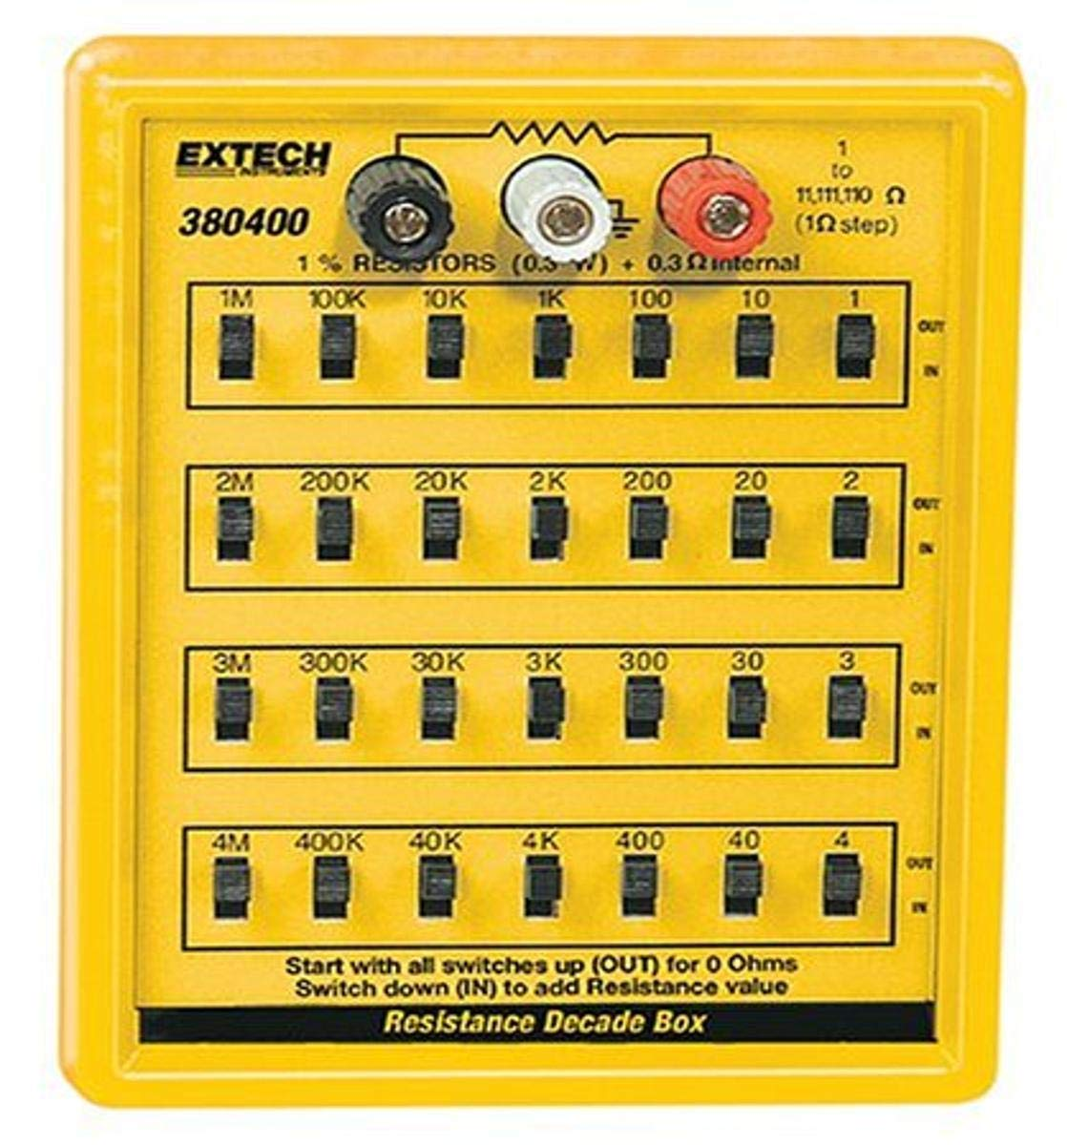

**Figure 5.Decade Resistance Box**

Suppose we want to make 1.427kΩ or 1427Ω resistance then we need to turn on a few switches into our decade resistance box those are 1kΩ=1000Ω, 400Ω, 20Ω, 4Ω, 3Ω or (1000+400+200+4+3) Ω =1427 ohm and now we get our resistance value what we need into our circuit.

**Conclusion:**

In experiment 6, we calculate Thevenin equivalent circuit theoretically and using PSpice simulation. In our actual lab, we use a decade resistance box to get value in the resistance into our circuit but in PSpice, we don't need it. Now we know how to work Thevenin's equivalent circuit and this circuit made our life easy. If we know Voltage and Resistance in a complex circuit then we make a simple series of Thevenin's equivalent circuit, so it is very easy to make simple series circuit.